Name: **Tushar Nankani** Roll No: **1902112** Batch: **C23**

**Microprocessor: Experiment 10**

**Aim**: Mixed Language program to increment, decrement the size of the cursor and to disable it.

**Theory:**

Mixed-language programming is the process of building programs in which the source code is written in two or more languages.

It allows you to:

• Call existing code that is written in another language

• Use procedures that may be difficult to implement in a particular language

• Gain advantages in processing speeds

Mixed-language programming is possible between Intel Fortran and other languages.

Although other languages (such as assembly language) are discussed, the primary focus of this section is programming using Intel Fortran and C/C++ . Mixed language programming between these two languages is relatively straightforward because each language implements functions, subroutines, and procedures in approximately the same way.

INT 10h / AH = 01h - set text-mode cursor shape.

input:

CH = cursor start line (bits 0-4) and options (bits 5-7).

CL = bottom cursor line (bits 0-4).

When bits 6-5 of CH are set to 00, the cursor is visible, to hide a cursor set these bits to 01 (this CH value will hide a cursor: 28h - 00101000b). Bit 7 should always be zero.

INT 20h - “exit program” system call

**CODE:**

#include<stdio.h>

#include<conio.h>

void main()

{

int choice, count=1;

clrscr();

while(choice != 4)

{

printf("\nEnter choice");

printf("\n1. Increment cursor size");

printf("\n2. Decrement cursor size");

printf("\n3. Disable cursor");

printf("\n4. Exit\nYou chose: ");

scanf("%d", &choice);

switch(choice)

{

case 1 :

count++;

asm mov cx, count;

asm mov ah, 01h;

asm INT 10h;

break;

case 2:

count--;

asm mov cx, count;

asm mov ah, 01h;

asm INT 10h;

break;

case 3:

asm mov cl, 20h;

asm mov ah, 01h;

asm INT 10h;

break;

}

}

}

**OUTPUT:**

**Increase size**

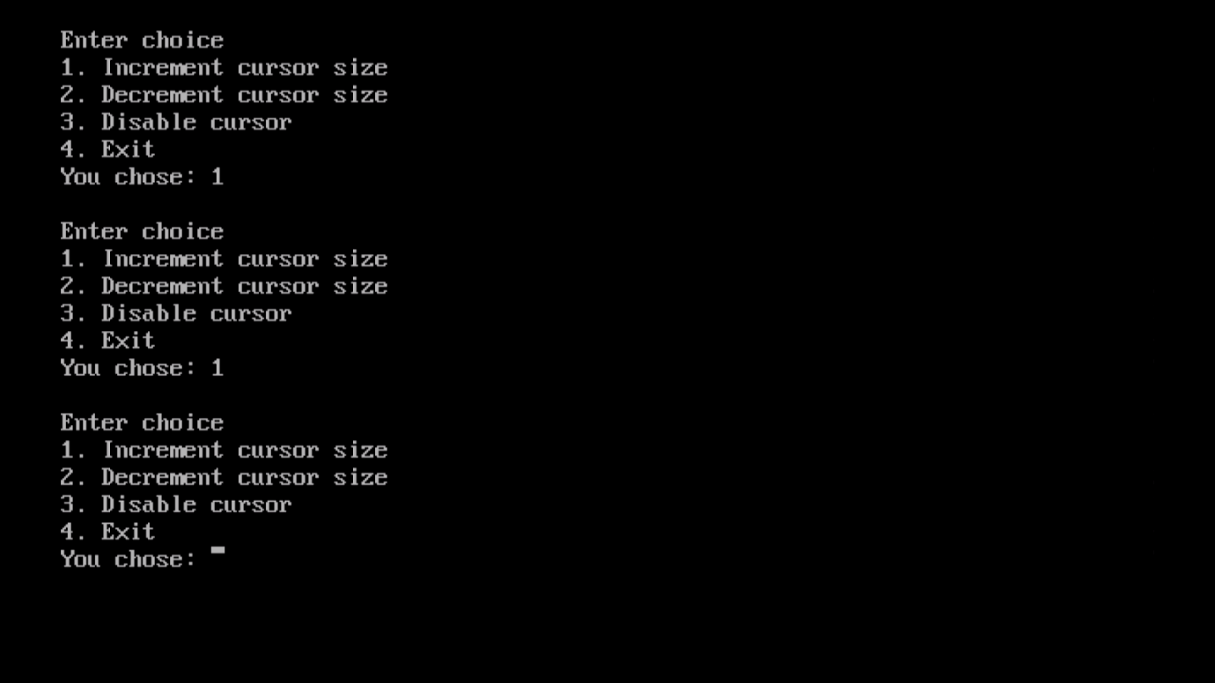

**Decrease size**

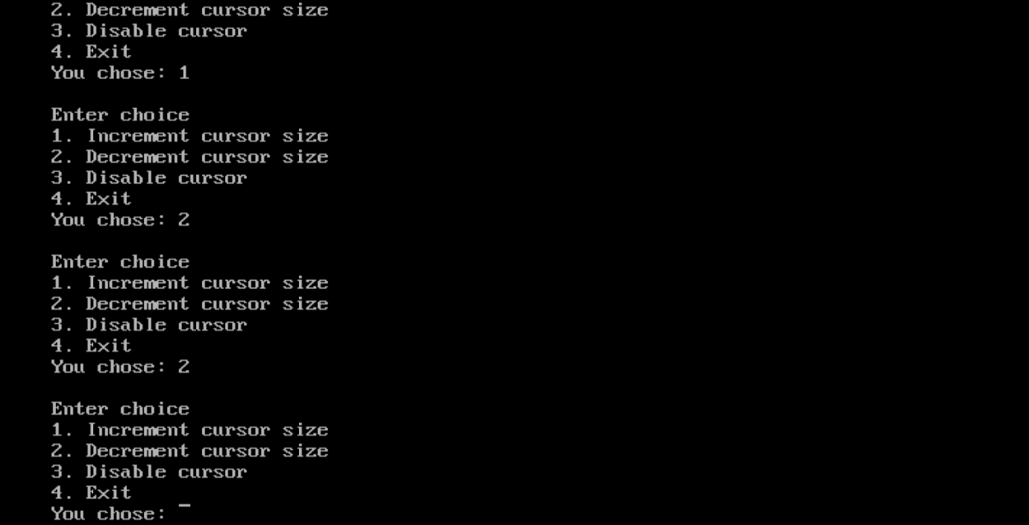

**Disable cursor**

